**Method Design**

**Method Design of Entity Class**

**MTD-01: Administrator**

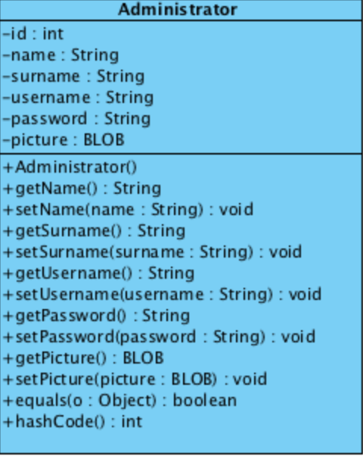

Attribute

|  |  |  |  |
| --- | --- | --- | --- |
| **ID** | **Name** | **Description** | **Remarks** |
| 1 | id | The attribute is used to identify id of the administrator | **Return type:** int |
| 2 | name | The attribute is used to identify name of the administrator | **Return type:** String |
| 3 | surname | The attribute is used to identify surname of the administrator | **Return type:** String |
| 4 | username | The attribute is used to identify username of the administrator | **Return type:** String |
| 5 | password | The attribute is used to identify password of the administrator | **Return type:** String |
| 6 | picture | The attribute is used to identify picture of the administrator | **Return type:** BLOB |

Methods

|  |  |  |  |
| --- | --- | --- | --- |
| **ID** | **Name** | **Description** | **Remarks** |
| 1 | equals() | The method is used for comparing between two objects. | **Return type:** Boolean  **Parameter:** o |
| 2 | hashCode() | The method is used for checking instance attributes value from override methods. | **Return type:** int |

**MTD-02: Customer**

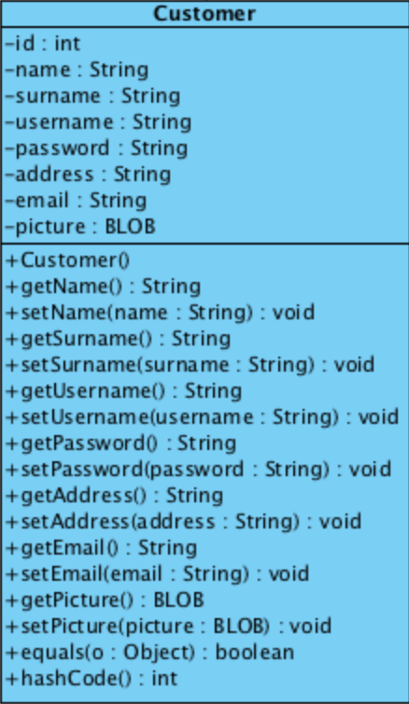

Attributes

|  |  |  |  |
| --- | --- | --- | --- |
| **ID** | **Name** | **Description** | **Remarks** |
| 1 | id | The attribute is used to identify id of the customer. | **Return type:** int |
| 2 | name | The attribute is used to identify name of the customer. | **Return type:** String |
| 3 | surname | The attribute is used to identify surname of the customer. | **Return type:** String |
| 4 | username | The attribute is used to identify username of the customer. | **Return type:** String |
| 5 | password | The attribute is used to identify password of the customer. | **Return type:** String |
| 6 | address | The attribute is used to identify address of the customer. | **Return type:** String |
| 7 | email | The attribute is used to identify email of the customer. | **Return type:** String |
| 8 | picture | The attribute is used to identify a picture input of the customer. | **Return type:** BLOB |

Methods

|  |  |  |  |
| --- | --- | --- | --- |
| **ID** | **Name** | **Description** | **Remarks** |
| 1 | equals() | The method is used for comparing between two objects. | **Return type:** Boolean  **Parameter:** o |
| 2 | hashCode() | The method is used for checking instance attributes value from override methods. | **Return type:** int |

**MTD-03: History**

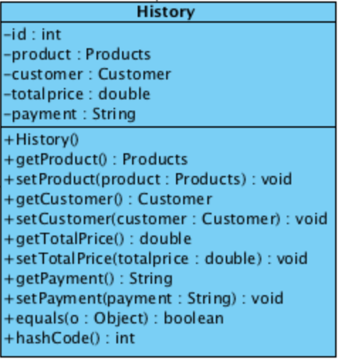

Attributes

|  |  |  |  |
| --- | --- | --- | --- |
| **ID** | **Name** | **Description** | **Remarks** |
| 1 | id | The attribute is used to identify id of the history | **Return type:** int |
| 2 | product | The product object that identify a product in the history. | **Return type:** Products |
| 3 | customer | The customer object that identify a product in the history. | **Return type:** Customer |
| 4 | totalprice | The attribute is used to identify total price in the history. | **Type value:** double |
| 5 | payment | The attribute is used to identify payment option in the history. | **Type value:** String |

Methods

|  |  |  |  |
| --- | --- | --- | --- |
| **ID** | **Name** | **Description** | **Remarks** |
| 1 | equals() | The method is used for comparing between two objects. | **Return type:** Boolean  Parameter: o |
| 2 | hashCode() | The method is used for checking instance attributes value from override methods. | **Return type:** int |

**MTD-04: Product**

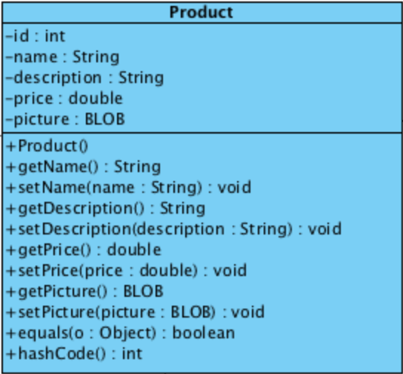

Attributes

|  |  |  |  |
| --- | --- | --- | --- |
| **ID** | **Name** | **Description** | **Remarks** |
| 1 | id | The attribute is used to identify id of the product. | **Return type:** int |
| 2 | name | The attribute is used to identify name of the product. | **Return type:** String |
| 3 | description | The attribute is used to identify description of the product. | **Return type:** String |
| 4 | price | The attribute is used to identify price of the product. | **Return type:** String |
| 5 | picture | The attribute is used to identify a picture input of the product. | **Type value:** BLOB |

Methods

|  |  |  |  |
| --- | --- | --- | --- |
| **ID** | **Name** | **Description** | **Remarks** |
| 1 | equals() | The method is used for comparing between two objects. | **Return type:** Boolean  **Parameter:** o |
| 2 | hashCode() | The method is used for checking instance attributes value from override methods. | **Return type:** int |

**MTD-05: ShoppingCart**

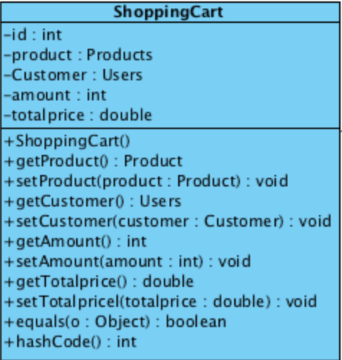

Attributes

|  |  |  |  |
| --- | --- | --- | --- |
| **ID** | **Name** | **Description** | **Remarks** |
| 1 | id | The attribute is used to identify id of the administrator | **Return type:** int |
| 2 | product | The product object that identify a product in shopping cart. | **Return type:** String |
| 3 | customer | The customer object that identify a product in shopping cart. | **Return type:** Customer |
| 4 | amount | The attribute is used to identify amount in the shopping cart. | **Return type:** int |
| 5 | totalprice | The attribute is used to identify total price in the shopping cart. | **Return type:** double |

Methods

|  |  |  |  |
| --- | --- | --- | --- |
| **ID** | **Name** | **Description** | **Remarks** |
| 1 | equals() | The method is used for compare between two objects. | **Return type:** Boolean  **Parameter:** o |
| 2 | hashCode() | The method is used for check instance attributes value from override methods. | **Return type:** int |

**Method design of Administrators’ MVC**

**MTD-06: AdministratorController**

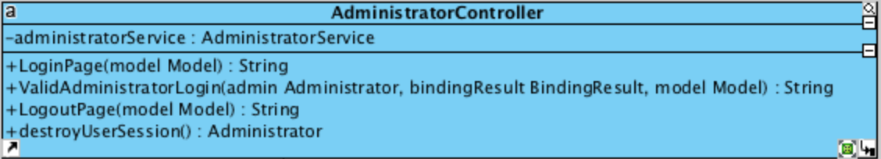

Attributes

|  |  |  |  |
| --- | --- | --- | --- |
| **ID** | **Name** | **Description** | **Remarks** |
| 1 | administratorService | The object that related to AdministratorService class. | **Return type:** AdministratorService |

Methods

|  |  |  |  |
| --- | --- | --- | --- |
| **ID** | **Name** | **Description** | **Remarks** |
| 1 | LoginPage() | The method is used for providing the login page. | **Return type:** String  **Parameter:** model |
| 2 | ValidAdministratorLogin() | The method is used for checking valid the username and password that match with the database. | **Return type:** String  **Parameter:** admin, bindingResult, model |
| 3 | LogoutPage() | The method is used for providing the logout page. | **Return type:** String  **Parameter:** model |
| 4 | destroyUserSession() | The method is used for destroying session when admin logout from website. | **Return type:** Admininstrator |

**MTD-07: AdministratorDAO**

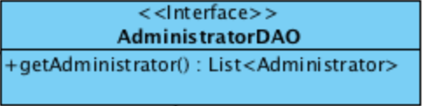

Methods

|  |  |  |  |
| --- | --- | --- | --- |
| **ID** | **Name** | **Description** | **Remarks** |
| 1 | getAdministrator() | The method is used for getting administrator list from database. | **Return type:** List<Admininstrator> |

**MTD-08: AdministratorDAOImpl**

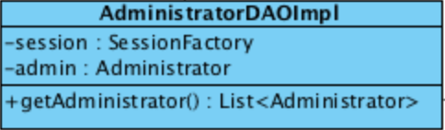

Attributes

|  |  |  |  |
| --- | --- | --- | --- |
| **ID** | **Name** | **Description** | **Remarks** |
| 1 | session | The object is used for collect a session after admin and customer login successful. | **Return type:** SessionFactory |
| 2 | admin | The object that related to Administrator class. | **Return type:** Administrator |

Methods

|  |  |  |  |
| --- | --- | --- | --- |
| **ID** | **Name** | **Description** | **Remarks** |
| 1 | getAdministrator() | The method is used for getting administrator list from database. | **Return type:** List<Admininstrator> |

**MTD-09: AdministratorService**

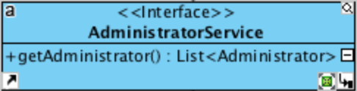

Methods

|  |  |  |  |
| --- | --- | --- | --- |
| **ID** | **Name** | **Description** | **Remarks** |
| 1 | getAdministrator() | The method is used for getting administrator list from database. | **Return type:** List<Admininstrator> |

**MTD-10: AdministratorServiceImpl**

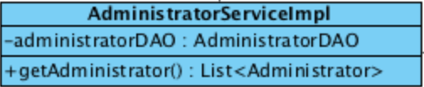

Attributes

|  |  |  |  |
| --- | --- | --- | --- |
| **ID** | **Name** | **Description** | **Remarks** |
| 1 | administratorDAO | The object that related to AdministratorDAO class. | **Return type:** AdministratorDAO |

Methods

|  |  |  |  |
| --- | --- | --- | --- |
| **ID** | **Name** | **Description** | **Remarks** |
| 1 | getAdministrator() | The method is used for getting administrator list from database. | **Return type:** List<Admininstrator> |

**Method design of Customers’ MVC**

**MTD-11: CustomerController**

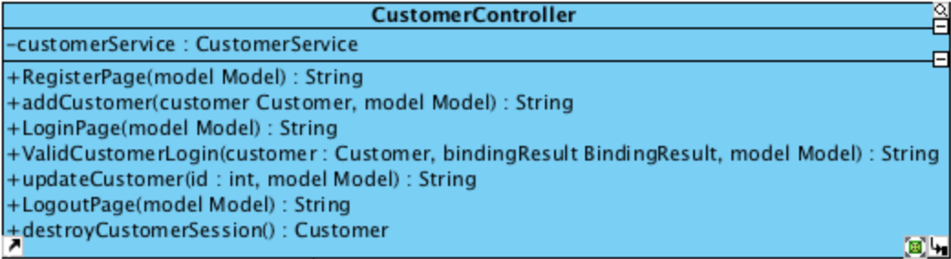

Attributes

|  |  |  |  |
| --- | --- | --- | --- |
| **ID** | **Name** | **Description** | **Remarks** |
| 1 | customerService | The object that related to CustomerService class. | **Return type:** CustomerService |

Methods

|  |  |  |  |
| --- | --- | --- | --- |
| **ID** | **Name** | **Description** | **Remarks** |
| 1 | RegisterPage() | The method is used for providing the register page to the customer. | **Return type:** String  **Parameter:** model |
| 2 | addCustomer() | The method is used for adding customer into the database when customer finishes registration. | **Return type:** String  **Parameter:** customer, model |
| 3 | LoginPage() | The method is used for providing the login page to the customer. | **Return type:** String  **Parameter:** model |
| 4 | ValidCustomerLogin() | The method is used for checking valid the username and password that match with the database. | **Return type:** String  **Parameter:** customer, model, bindingResult |
| 5 | updateCustomer() | The method is used for updating the customers’ information into the database | **Return type:** String  **Parameter:** id, model |
| 6 | LogoutPage() | The method is used for providing the logout page to the customer. | **Return type:** String  **Parameter:** model |
| 7 | destroyCustomerSession() | The method is used for destroying session when customer logout from website. | **Return type:** Customer |

**MTD-12: CustomerDAO**

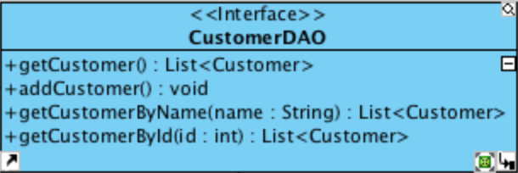

Methods

|  |  |  |  |
| --- | --- | --- | --- |
| **ID** | **Name** | **Description** | **Remarks** |
| 1 | getCustomer() | The method is used for getting a customer list from database. | **Return type:** List<Customer> |
| 2 | addCustomer() | The method is used for adding customer into the database when customer finishes registration. | **Return type:** void |
| 3 | getCustomerByName() | The method is used for using name character to find the customer from the list. | **Return type:** List<Customer>  **Parameter:** name |
| 4 | getCustomerById() | The method is used for using id character to find the customer from the list. | **Return type:** List<Customer>  **Parameter:** id |

**MTD-13: CustomerDAOImpl**

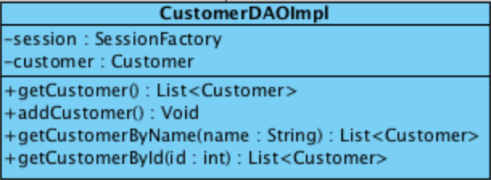

Attributes

|  |  |  |  |
| --- | --- | --- | --- |
| **ID** | **Name** | **Description** | **Remarks** |
| 1 | session | The object is used for collect a session after admin and customer login successful. | **Return type:** SessionFactory |
| 2 | customer | The object that related to Customer class. | **Return type:** Customer |

Methods

|  |  |  |  |
| --- | --- | --- | --- |
| **ID** | **Name** | **Description** | **Remarks** |
| 1 | getCustomer() | The method is used for getting a customer list from database. | **Return type:** List<Customer> |
| 2 | addCustomer() | The method is used for adding customer into the database when customer finishes registration. | **Return type:** void |
| 3 | getCustomerByName() | The method is used for using name character to find the customer from the list. | **Return type:** List<Customer>  **Parameter:** name |
| 4 | getCustomerById() | The method is used for using id character to find the customer from the list. | **Return type:** List<Customer>  **Parameter:** id |

**MTD-14: CustomerService**

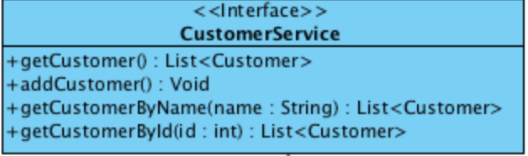

Methods

|  |  |  |  |
| --- | --- | --- | --- |
| **ID** | **Name** | **Description** | **Remarks** |
| 1 | getCustomer() | The method is used for getting a customer list from database. | **Return type:** List<Customer> |
| 2 | addCustomer() | The method is used for adding customer into the database when customer finishes registration. | **Return type:** void |
| 3 | getCustomerByName() | The method is used for using name character to find the customer from the list. | **Return type:** List<Customer>  **Parameter:** name |
| 4 | getCustomerById() | The method is used for using id character to find the customer from the list. | **Return type:** List<Customer>  **Parameter:** id |

**MTD-15: CustomerServiceImpl**

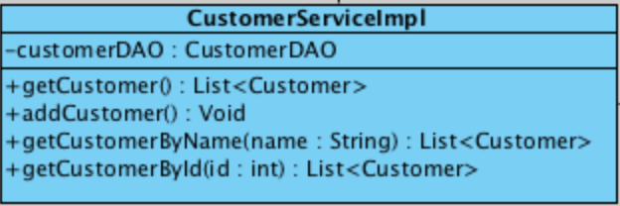

Attributes

|  |  |  |  |
| --- | --- | --- | --- |
| **ID** | **Name** | **Description** | **Remarks** |
| 1 | customerDAO | The object that related to CustomerDAO class. | **Return type:** CustomerDAO |

Methods

|  |  |  |  |
| --- | --- | --- | --- |
| **ID** | **Name** | **Description** | **Remarks** |
| 1 | getCustomer() | The method is used for getting a customer list from database. | **Return type:** List<Customer> |
| 2 | addCustomer() | The method is used for adding customer into the database when customer finishes the registration. | **Return type:** void |
| 3 | getCustomerByName() | The method is used for using name character to get the customer from the list. | **Return type:** List<Customer>  **Parameter:** name |
| 4 | getCustomerById() | The method is used for using id character to get the customer from the list. | **Return type:** List<Customer>  **Parameter:** id |

**Method design of Products’ MVC**

**MTD-16: ProductController**

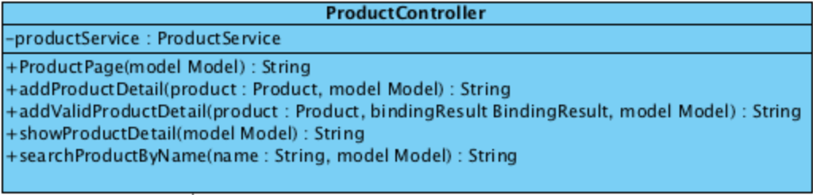

Attributes

|  |  |  |  |
| --- | --- | --- | --- |
| **ID** | **Name** | **Description** | **Remarks** |
| 1 | productService | The object that related to ProductService class. | **Return type:** ProductService |

Methods

|  |  |  |  |
| --- | --- | --- | --- |
| **ID** | **Name** | **Description** | **Remarks** |
| 1 | ProductPage() | The method is used for providing the product page to the website. | **Return type:** String  **Parameter:** model |
| 2 | addProductDetail() | The method is used for adding a products’ description into the database. | **Return type:** String  **Parameter:** product, model |
| 3 | addValidProductDetail() | The method is used for checking valid of products’ description. | **Return type:** String  **Parameter:** product, bindingResult, model |
| 4 | showProductDetail() | The method is used for providing the products’ description. | **Return type:** String  **Parameter:** model |
| 5 | searchProductByName() | The method is used for getting the products’ description from the name character. | **Return type:** String  **Parameter:** name, model |

**MTD-17: ProductDAO**

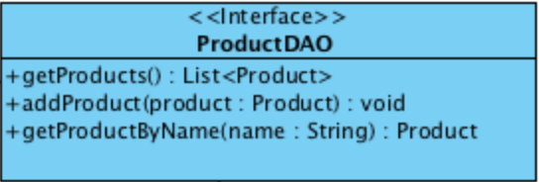

Methods

|  |  |  |  |
| --- | --- | --- | --- |
| **ID** | **Name** | **Description** | **Remarks** |
| 1 | getProducts() | The method is used for getting a product list from the database. | **Return type:** List<Product> |
| 2 | addProduct () | The method is used for adding a products’ description into the database. | **Return type:** void  **Parameter:** product |
| 3 | getProductByName() | The method is used for getting the products’ description from the database by name character. | **Return type:** Product  **Parameter:** name |

**MTD-18: ProductDAOImpl**

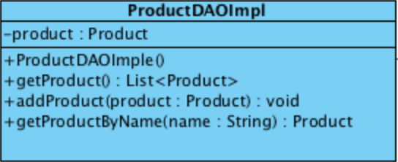

Attributes

|  |  |  |  |
| --- | --- | --- | --- |
| **ID** | **Name** | **Description** | **Remarks** |
| 1 | product | The object that related to Product class. | **Return type:** Product |

Methods

|  |  |  |  |
| --- | --- | --- | --- |
| **ID** | **Name** | **Description** | **Remarks** |
| 1 | getProducts() | The method is used for getting a product list from the database. | **Return type:** List<Product> |
| 2 | addProduct () | The method is used for adding a products’ description into the database. | **Return type:** void  **Parameter:** product |
| 3 | getProductByName() | The method is used for getting the products’ description from the database by name character. | **Return type:** Product  **Parameter:** name |

**MTD-19: ProductService**

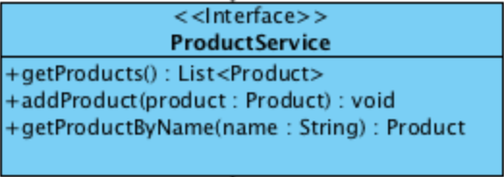

Methods

|  |  |  |  |
| --- | --- | --- | --- |
| **ID** | **Name** | **Description** | **Remarks** |
| 1 | getProducts() | The method is used for getting a product list from the database. | **Return type:** List<Product> |
| 2 | addProduct () | The method is used for adding a products’ description into the database. | **Return type:** void  **Parameter:** product |
| 3 | getProductByName() | The method is used for getting the products’ description from the database by name character. | **Return type:** Product  **Parameter:** name |

**MTD-20: ProductServiceImpl**

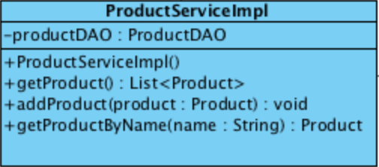

Attributes

|  |  |  |  |
| --- | --- | --- | --- |
| **ID** | **Name** | **Description** | **Remarks** |
| 1 | productDAO | The object that related to ProductDAO class. | **Return type:** ProductDAO |

Methods

|  |  |  |  |
| --- | --- | --- | --- |
| **ID** | **Name** | **Description** | **Remarks** |
| 1 | getProducts() | The method is used for getting a product list from the database. | **Return type:** List<Product> |
| 2 | addProduct () | The method is used for adding a products’ description into the database. | **Return type:** void  **Parameter:** product |
| 3 | getProductByName() | The method is used for getting the products’ description from the database by name character. | **Return type:** Product  **Parameter:** name |

**Method design of Shopping Carts’ MVC**

**MTD-21: ShoppingCartController**

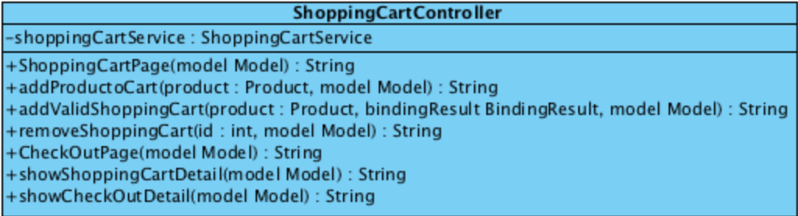

Attributes

|  |  |  |  |
| --- | --- | --- | --- |
| **ID** | **Name** | **Description** | **Remarks** |
| 1 | shoppingCartService | The object that related to ShoppingCartService service class. | **Return type:** ShoppingCartService |

Methods

|  |  |  |  |
| --- | --- | --- | --- |
| **ID** | **Name** | **Description** | **Remarks** |
| 1 | ShoppingCartPage() | The method is used for providing the product page to the website. | **Return type:** String  **Parameter:** model |
| 2 | addProductCart() | The method is used for adding a products’ description into the database. | **Return type:** String  **Parameter:** product, model |
| 3 | addValidShoppingCart() | The method is used for checking valid in order to add a products’ description before add into the database. | **Return type:** String  **Parameter:** product, bindingResult, model |
| 4 | removeShoppingCart() | The method is used for checking valid a products’ description. | **Return type:** int  **Parameter:** product, model |
| 5 | CheckOutPage() | The method is used for providing the products’ description. | **Return type:** String  **Parameter:** model |
| 6 | showShoppingCart() | The method is used for getting the shopping car list of each customer. | **Return type:** String  **Parameter:** model |
| 7 | showCheckOutDetail() | The method is used for providing the shopping carts’ description and payment option in the check out page | **Return type:** String  **Parameter:** model |

**MTD-22: ShoppingCartDAO**

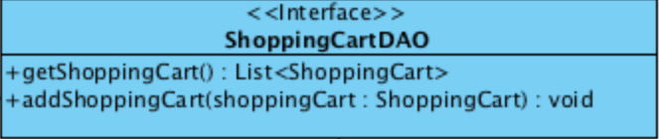

Methods

|  |  |  |  |
| --- | --- | --- | --- |
| **ID** | **Name** | **Description** | **Remarks** |
| 1 | getShoppingCart() | The method is used for getting a shopping cart list from the database. | **Return type:** List<ShoppingCart> |
| 2 | addShoppingCart () | The method is used for adding a products’ description into the database. | **Return type:** void  **Parameter:** shoppingCart |

**MTD-23: ShoppingCartDAOImpl**

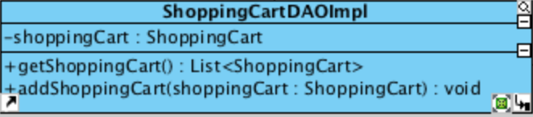

Attributes

|  |  |  |  |
| --- | --- | --- | --- |
| **ID** | **Name** | **Description** | **Remarks** |
| 1 | shoppingCart | The object that related to ShoppingCart class. | **Return type:** ShoppingCart |

Methods

|  |  |  |  |
| --- | --- | --- | --- |
| **ID** | **Name** | **Description** | **Remarks** |
| 1 | getShoppingCart() | The method is used for getting a shopping cart list from the database. | **Return type:** List<ShoppingCart> |
| 2 | addShoppingCart () | The method is used for adding a products’ description into the database. | **Return type:** void  **Parameter:** shoppingCart |

**MTD-24: ShoppingCartService**

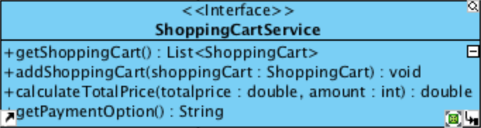

Methods

|  |  |  |  |
| --- | --- | --- | --- |
| **ID** | **Name** | **Description** | **Remarks** |
| 1 | getShoppingCart() | The method is used for getting a shopping cart list from the database. | **Return type:** List<ShoppingCart> |
| 2 | addShoppingCart () | The method is used for adding a products’ description into the database. | **Return type:** void  **Parameter:** shoppingCart |
| 3 | calculateTotalPrice() | The method is used for calculating total of product in the shopping cart page. | **Return type:** double  **Parameter:** totalprice, amount |
| 4 | getPaymentOption() | The method is used for providing a payment option in the shopping cart page. | **Return type:** String |

**MTD-25: ShoppingCartServiceImpl**

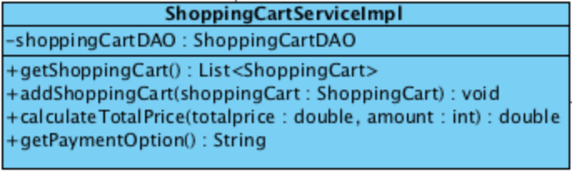

Attributes

|  |  |  |  |
| --- | --- | --- | --- |
| **ID** | **Name** | **Description** | **Remarks** |
| 1 | shoppingCartDAO | The object that related to ShoppingCartDAO class. | **Return type:** ShoppingCartDAO |

Methods

|  |  |  |  |
| --- | --- | --- | --- |
| **ID** | **Name** | **Description** | **Remarks** |
| 1 | getShoppingCart() | The method is used for getting a shopping cart list from the database. | **Return type:** List<ShoppingCart> |
| 2 | addShoppingCart () | The method is used for adding a products’ description into the database. | **Return type:** void  **Parameter:** shoppingCart |
| 3 | calculateTotalPrice() | The method is used for calculating total of product in the shopping cart page. | **Return type:** double  **Parameter:** totalprice, amount |
| 4 | getPaymentOption() | The method is used for providing a payment option in the shopping cart page. | **Return type:** String |

**MTD-26: ShoppingCartDAO**



Methods

|  |  |  |  |
| --- | --- | --- | --- |
| **ID** | **Name** | **Description** | **Remarks** |
| 1 | getShoppingCart() | The method is used for getting a shopping cart list from the database. | **Return type:** List<ShoppingCart> |
| 2 | addShoppingCart () | The method is used for adding a products’ description into the database. | **Return type:** void  **Parameter:** shoppingCart |

**MTD-27: ShoppingCartDAOImpl**

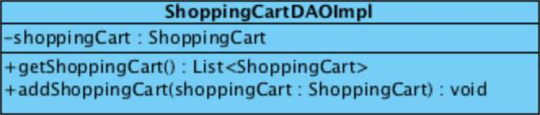

Attributes

|  |  |  |  |
| --- | --- | --- | --- |
| **ID** | **Name** | **Description** | **Remarks** |
| 1 | shoppingCart | The object that related to ShoppingCart class. | **Return type:** ShoppingCart |

Methods

|  |  |  |  |
| --- | --- | --- | --- |
| **ID** | **Name** | **Description** | **Remarks** |
| 1 | getShoppingCart() | The method is used for getting a shopping cart list from the database. | **Return type:** List<ShoppingCart> |
| 2 | addShoppingCart () | The method is used for adding a products’ description into the database. | **Return type:** void  **Parameter:** shoppingCart |

**Method design of Histories’’ MVC**

**MTS-28: HistoryController**

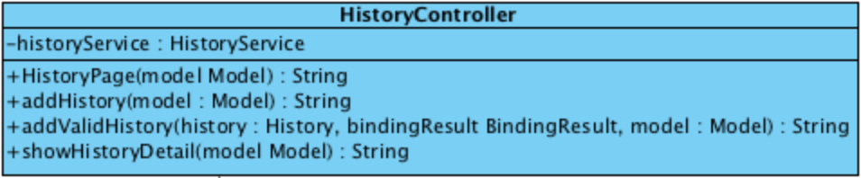

Attributes

|  |  |  |  |
| --- | --- | --- | --- |
| **ID** | **Name** | **Description** | **Remarks** |
| 1 | historyService | The object that related to HistoryService class. | **Return type:** HistoryService |

Methods

|  |  |  |  |
| --- | --- | --- | --- |
| **ID** | **Name** | **Description** | **Remarks** |
| 1 | HistoryPage() | The method is used for providing the history page to the website. | **Return type:** String  **Parameter:** model |
| 2 | addHistory () | The method is used for adding a histories’ description into the database. | **Return type:** String  **Parameter:** model |
| 3 | addValidHistory() | The method is used for checking valid of histories’ description. | **Return type:** String  **Parameter:** history, bindingResult, model |
| 4 | showHistoryDetail() | The method is used for providing a histories’ description in the history page | **Return type:** String  **Parameter:** model |

**MTD-29: HistoryDAO**

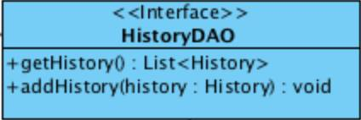

Methods

|  |  |  |  |
| --- | --- | --- | --- |
| **ID** | **Name** | **Description** | **Remarks** |
| 1 | getHistory () | The method is used for getting a history list from the database. | **Return type:** List<History> |
| 2 | addHistory () | The method is used for adding a histories’ description into the database. | **Return type:** void  **Parameter:** history |

**MTD-30: HistoryDAOImpl**

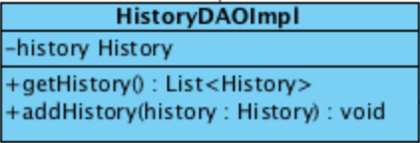

Attributes

|  |  |  |  |
| --- | --- | --- | --- |
| **ID** | **Name** | **Description** | **Remarks** |
| 1 | history | The object that related to History class. | **Return type:** History |

Methods

|  |  |  |  |
| --- | --- | --- | --- |
| **ID** | **Name** | **Description** | **Remarks** |
| 1 | getHistory () | The method is used for getting a history list from the database. | **Return type:** List<History> |
| 2 | addHistory () | The method is used for adding a histories’ description into the database. | **Return type:** void  **Parameter:** history |